AML DASHBOARD

Using Microsoft Power BI

Project Report
Submitted By:
Name: Swarnalakshmi J
Roll.no: E25FA045
Tool Used: Microsoft Power BI Desktop

Power BI Report
AML Transaction & Fraud Analysis Dashboard

1. Introduction
Anti-Money Laundering (AML) monitoring is a core control function in banking and financial services. Institutions process very large volumes of transactions every day, and only a very small share of them are fraudulent or suspicious. Finding these few transactions among millions of normal ones requires analysis that is both quick and easy to read.
This report documents the AML Transaction & Fraud Analysis dashboard built in Microsoft Power BI Desktop using DATASET_5. The dashboard summarises overall transaction activity, shows how fraudulent transactions behave over time, and breaks down the alerts raised by the monitoring system by type. It consists of three report pages: the main analysis page, an interactive version of the dashboard with slicers, and a tooltip page.

2. Objectives
- To summarise overall transaction activity with headline KPIs.
- To compare fraudulent and non-fraudulent transactions by count and by value.
- To track transaction volume and fraudulent transaction volume across time.
- To analyse the alerts generated by the monitoring system by alert type.
- To make the dashboard interactive so users can filter it by fraud status and alert type.

3. Dataset Description
The Power BI model for DATASET_5 contains three tables. The fields used in the dashboard are listed below.
Table | Fields used | Description
Transactions | TIMESTAMP, IS_FRAUD | One row per transaction, with a time step and a flag showing whether it is fraudulent.
Accounts | Account records | Used to count the total number of accounts.
Alerts | ALERT_ID, ALERT_TYPE | Alerts raised by the AML monitoring system, classified by pattern type (CYCLE or FAN_IN).

The following DAX measures were created for the cards and charts: TOTAL TRANSACTION, TOTAL TRANSACTION AMOUNT, FRAUDULENT TRANSACTION (all in the Transactions table) and TOTAL ACCOUNT (in the Accounts table).

4. Tools Used
- Microsoft Power BI Desktop for data modelling, DAX measures and dashboard design.
- DAX (Data Analysis Expressions) for the calculated measures.
- A dark report theme for a clean, high-contrast layout.

5. Dashboard Overview
The main page, AML TRANSACTION & FRAUD ANALYSIS, gives a complete view of transaction and fraud activity on one screen. Key figures appear as cards on the left, time-series line charts sit in the centre, and the fraud and alert breakdown charts are on the right.
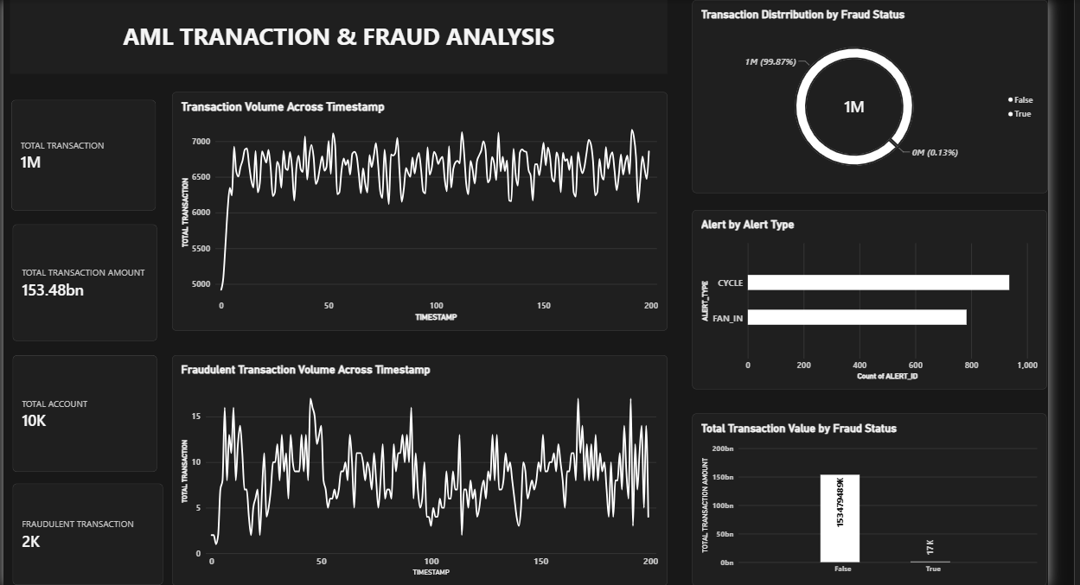
Figure 1: AML Transaction & Fraud Analysis dashboard (main page)

6. Key Performance Indicators (Cards)
Four KPI cards on the left of the dashboard present the most important figures immediately, so the user does not have to study every chart to understand the overall position.
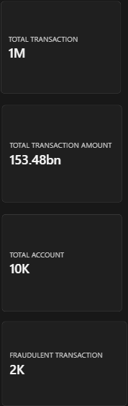
Figure 2: KPI cards
KPI | Value | Meaning
Total Transaction | 1M | Total number of transactions in the dataset.
Total Transaction Amount | 153.48bn | Combined value of all transactions.
Total Account | 10K | Number of distinct accounts in the data.
Fraudulent Transaction | 2K | Number of transactions flagged as fraud.

Purpose:
- To show the scale of activity being monitored.
- To show the size of the fraud problem against total activity.
- To give a quick summary without opening the detailed charts.

7. Visualizations Used

Transaction Volume Across Timestamp
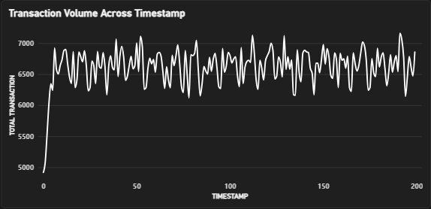
Figure 3: Transaction Volume Across Timestamp
A Line Chart is used to show the number of transactions at each timestamp, from 0 to about 200.
Volume rises sharply from about 5,000 at the start and settles into a stable band of roughly 6,200 to 7,100 transactions per timestamp. This suggests normal activity is steady, so any sudden deviation would stand out as unusual.
Purpose:
- To track transaction activity over time.
- To identify spikes or drops in volume.
- To establish a normal baseline for monitoring.

Fraudulent Transaction Volume Across Timestamp
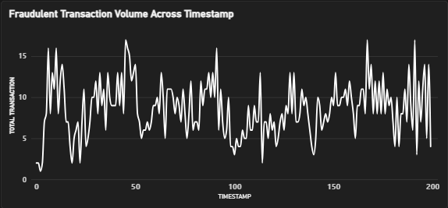
Figure 4: Fraudulent Transaction Volume Across Timestamp
A Line Chart is used to track only the fraudulent transactions at each timestamp.
Fraudulent transactions fluctuate between roughly 1 and 17 per timestamp. Unlike overall volume, the fraud line is irregular, with repeated peaks and dips and no steady pattern. This makes fraud harder to predict from volume alone.
Purpose:
- To observe when fraudulent activity rises or falls.
- To compare fraud behaviour with overall transaction behaviour.
- To help decide when closer monitoring is needed.

Transaction Distribution by Fraud Status
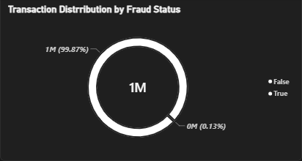
Figure 5: Transaction Distribution by Fraud Status
A Donut Chart is used to show the share of fraudulent and non-fraudulent transactions.
About 99.87% of transactions are not fraudulent and only about 0.13% are fraudulent. Fraud is therefore extremely rare in this dataset, which is why it is difficult to detect and why dedicated monitoring is needed.
Purpose:
- To show the proportion of fraud against normal transactions.
- To highlight how imbalanced the data is.
- To give context for the fraud KPI.

Alert by Alert Type
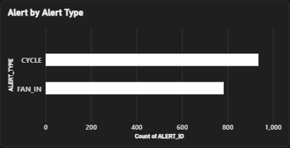
Figure 6: Alert by Alert Type
A Bar Chart is used to compare the number of alerts raised for each alert type.
Two alert types appear. CYCLE alerts number about 930 and FAN_IN alerts about 780, so cycle patterns are raised somewhat more often. A cycle pattern is where money moves through a chain of accounts and returns to its origin; a fan-in pattern is where many accounts send money to one account.
Purpose:
- To compare alert volumes by type.
- To identify the most common suspicious pattern.
- To help prioritise investigation effort.

Total Transaction Value by Fraud Status
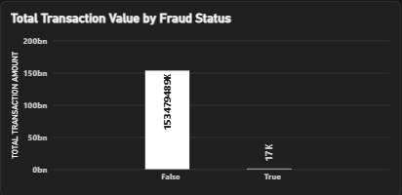
Figure 7: Total Transaction Value by Fraud Status
A Column Chart is used to compare the total value of non-fraudulent and fraudulent transactions.
Non-fraudulent transactions account for about 153.48bn, while fraudulent transactions total only about 17K. Fraud is very small both in count and in value, but the chart makes the gap between the two groups clear.
Purpose:
- To compare the financial value of fraud and normal activity.
- To understand the monetary exposure from fraud.
- To support the donut chart with value-based evidence.

8. Slicers Used
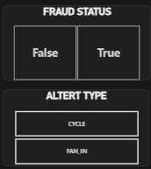
Figure 8: Fraud Status and Alert Type slicers
Two slicers were added on the interactive page to make the dashboard dynamic:
- Fraud Status (False / True)
- Alert Type (CYCLE / FAN_IN)
These slicers filter the whole page. For example, selecting True under Fraud Status shows only fraudulent transactions across all the cards and charts, and selecting an alert type focuses the alert analysis on that pattern.

9. Interactive AML Dashboard
The second page, INTERACTIVE AML DASH BOARD, keeps the same visuals as the main page and adds the slicer panel at the top left. It lets the user explore the data without changing the report design.
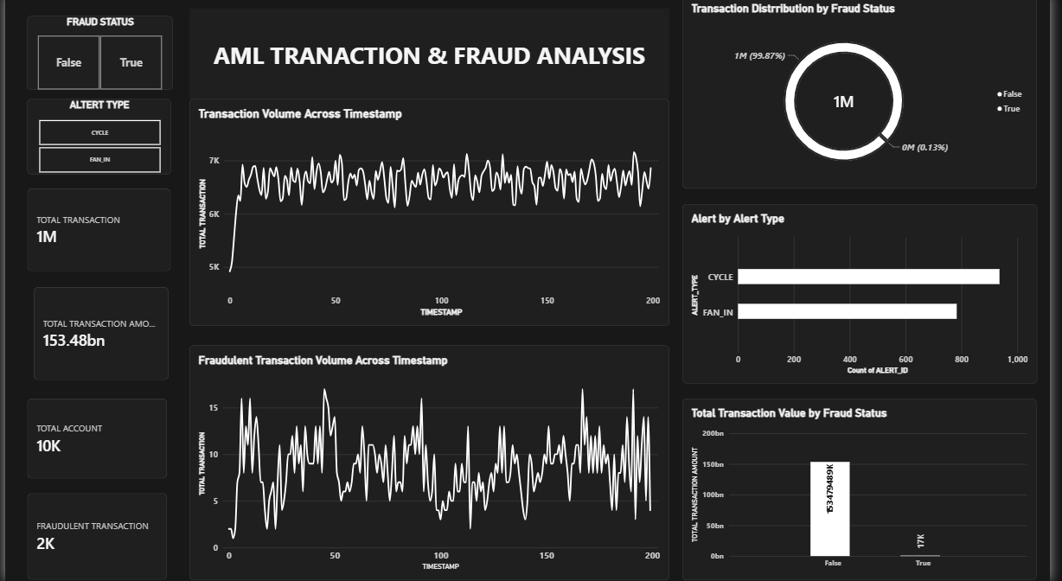
Figure 9: Interactive AML dashboard with slicers

10. Tooltip Page
The third page, AML TOOLTIP, is a custom tooltip page. It shows three cards (Total Transaction, Total Transaction Amount and Fraudulent Transaction) as a small pop-up when the user hovers over a chart, so the key figures for that data point appear without leaving the page.
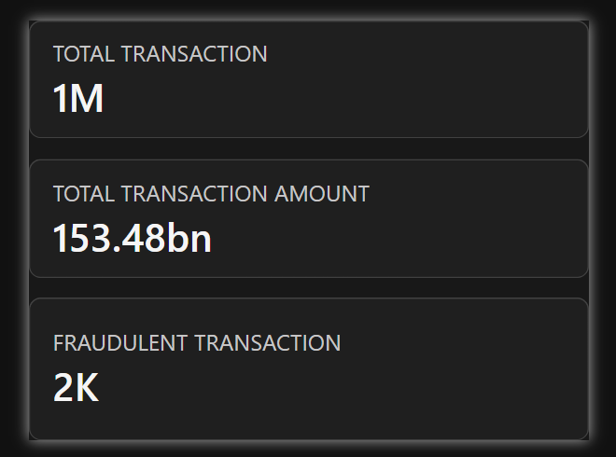
Figure 10: AML tooltip page

11. Key Insights
- The dataset holds about 1M transactions across 10K accounts, with a total value of 153.48bn.
- Fraud is extremely rare: about 0.13% of transactions (roughly 2K), worth only about 17K in total.
- Overall transaction volume is stable after an initial ramp-up, while fraudulent volume is irregular.
- CYCLE alerts (about 930) are more frequent than FAN_IN alerts (about 780).
- Slicers and tooltips let users check specific segments quickly.

12. Conclusion
The AML Transaction & Fraud Analysis dashboard turns a large transaction dataset into a clear, interactive view of fraud activity. The KPI cards give the overall position, the line charts show behaviour over time, the donut and column charts show how small the fraud share is, and the alert chart shows which suspicious patterns occur most often. With the slicers and tooltip page, the dashboard supports quick, focused review by an analyst.

